**IN3005 Computer Graphics**

**Coursework Report**

**Tayyab Hussain**

Description of the game:

Annotated Screenshot of top-down view:

KBM Controls:

Asset Listings:

URL: Date of Download: License:

Reflection: (PUT THIS RIGHT AT THE BOTTOM)

***Route and Camera***

Route:

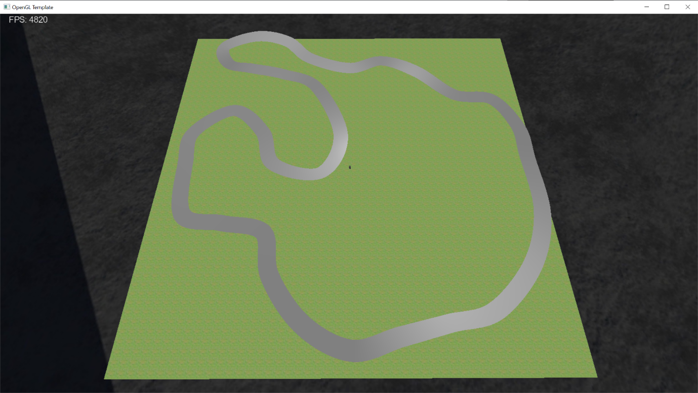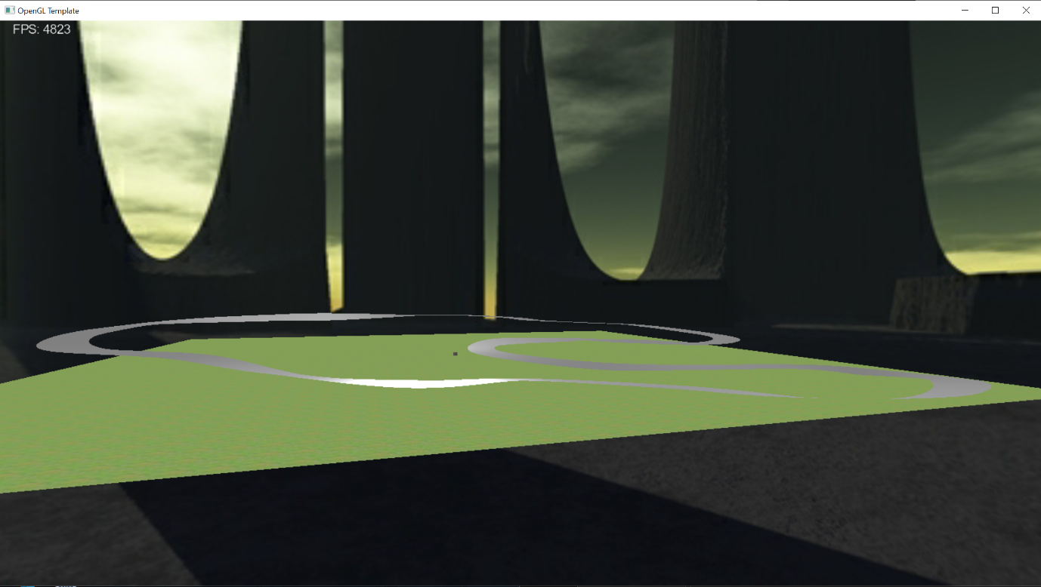This is the track I have created for my game. I implemented it using the Catmull-Rom spline. There are 33 points along the track, each with its own individual up-vector to create banked or off-camber corners.

After applying a texture to it, here is what the track looks like now: 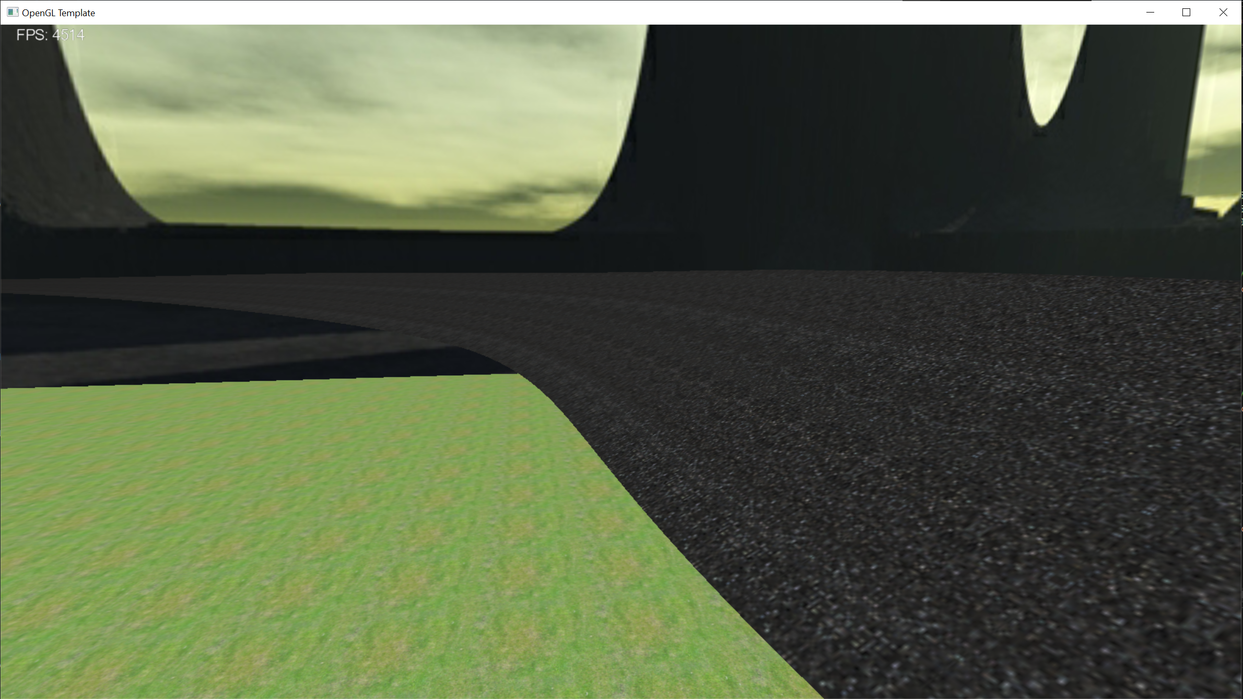

I added height-mapped terrain though it is very rudimentary. I designed it using Microsoft Paint 3D, so it doesn’t blend in well. I’m hoping that once I add some more meshes I can hide the rough edges of my heightmap.

I then placed my Tunnel primitive in 2 locations along the track and used a Catmull-Rom spline again to create 2 barricades on either side of the track. The barricades use the offset points (that create the track width) and a TNB frame from each of these points to position a new point above the current offset point in the direction of the centre line`s up vector.

I did have a few issues with the texturing of the barricades. Due to the fact that both the track and the barricades had different textures, but they were part of the same class, only one texture would be applied to both objects. I could not find an elegant solution to this problem. One thing I could’ve done is simply not apply a texture to the track or barricade, but I didn’t like how this looked. So instead, I created a new Catmull-Rom spline class and renamed it BarricadeSpline. This class is identical to the original in every way except that it doesn’t render anything other than the barricades and therefore I can use the main Catmull-Rom class to render that track and track texture and the barricade class to render the barricades and barricade texture.

This is what the track looks like as of now:

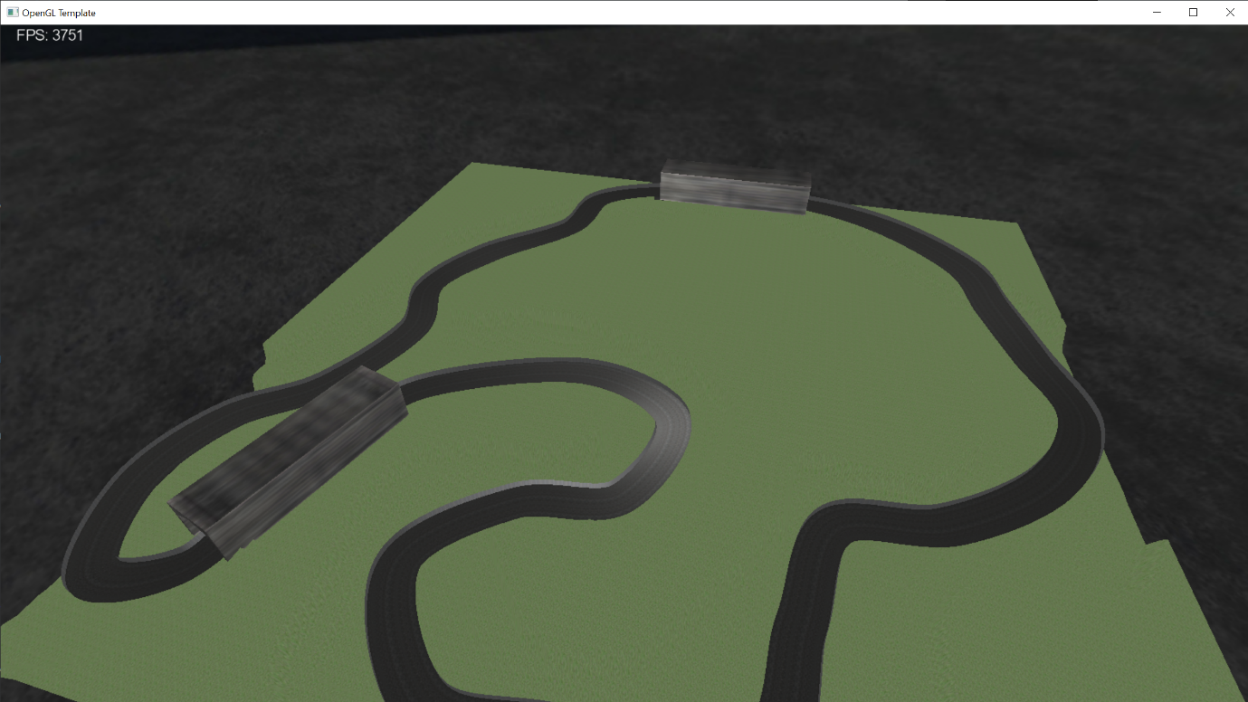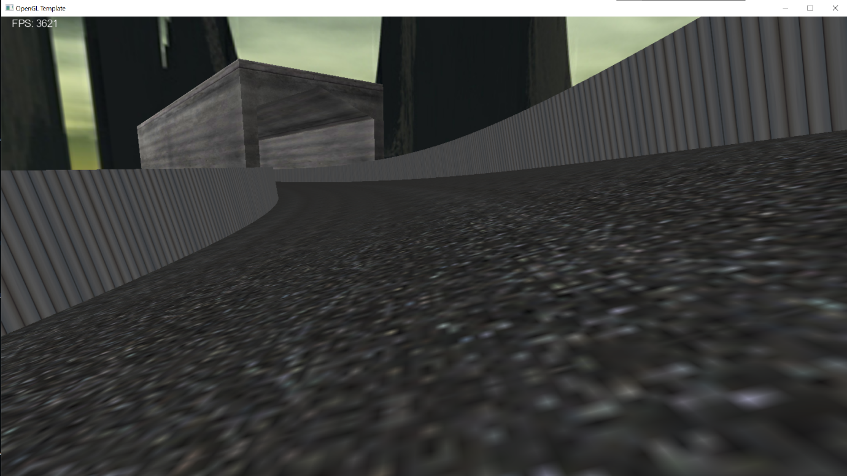

I also changed the skybox at this stage, to match the theme of my game more closely. This was the outcome: 